Cloud Computing Overview (AWS CLI)

HOS10: Comprehensive Hands on Skills

Developed by Marvin Gold 12/20/2020

School of Technology and Computing



**Learning Outcomes**

* Use everything we’ve learned throughout the course to get a development project started for a small team.

**Background**

For this final HOP you will have several tasks that you must complete based off this story using the AWS CLI.

You are part of “SomeCompany” a growing tech start-up. You are starting a new project with a team of four:

Joanne

Annamaria

Nzinga

ZhangHe

**References**

[*https://docs.aws.amazon.com/*](https://docs.aws.amazon.com/)

**Step 1: Log onto your Amazon EC2 Instance**

Log onto your Amazon EC2 instance using either OpenSSH, Putty, or from the AWS Management Console using ‘EC2 Instance Connect’ (shown below). Note all IP addresses used in this series of Hands on Skills will be released by the time we start class.

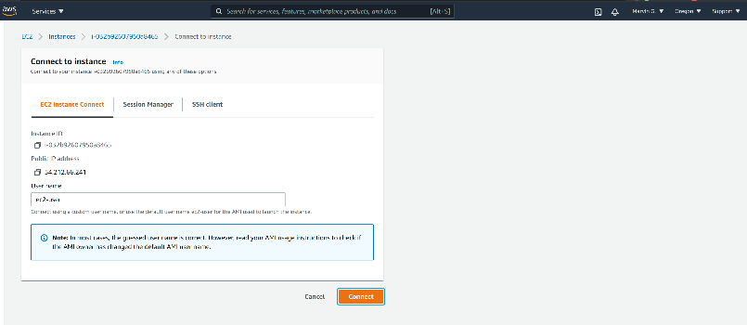

If you receive an error that you must first set your AWS Region and you must configure your AWS CLI, please follow these instructions.

<https://docs.aws.amazon.com/cli/latest/userguide/cli-configure-quickstart.html>  
  
Remember, do not use your root *account* for these operations. You should be using another IAM user. You should not have access keys to your root account.

**Step 2: Create the Users and groups**

Create the following users

Joanne -- Development

Annamaria -- Tester

Nzinga -- Tester

ZhangHe – Development, Admin

**SCREENSHOT of Created Users**

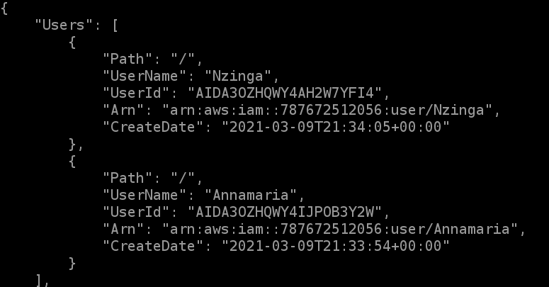

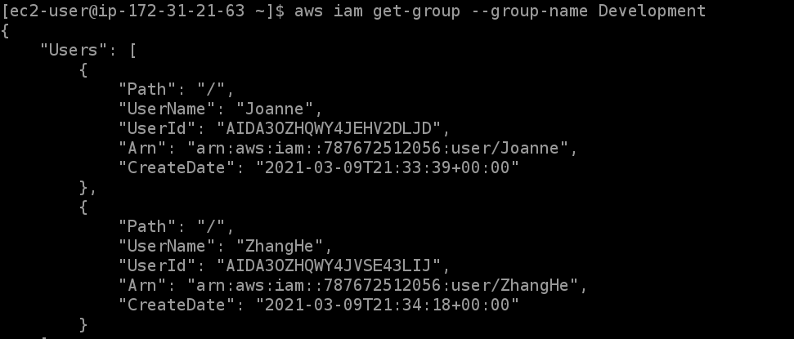

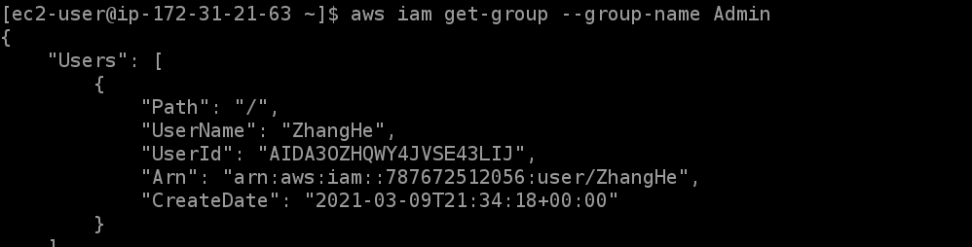

They will all need passwords, and they must be required to reset the passwords. Joanne and ZhangHe are developers so they will need Access Keys.

**SCREENSHOT of IAM Console user page “Access Key Age” column**

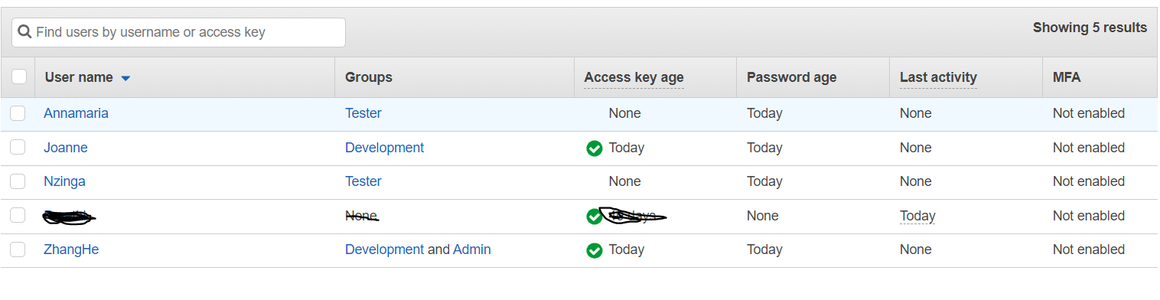

**Step 3: Create Groups**

Create 3 groups with the following permissions

Then take **SCREENSHOTS** of each group and its permissions.  
Development

* Amazon S3 Full Access
* Amazon SNS Full Access
* Amazon SQS Full Access
* Amazon EC2 Full Access
* Amazon DynamoDB Full Access

Tester

* Amazon S3 Read Only
* Amazon EC2 Read Only
* Amazon DynamoDB Read Only
* Amazon SNS Read Only

Admin

* Administrator Access

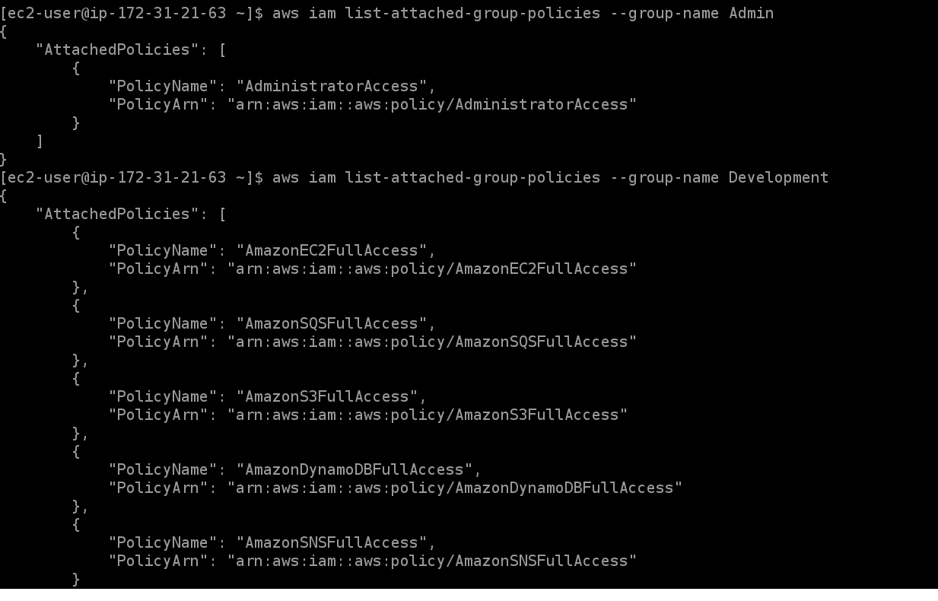

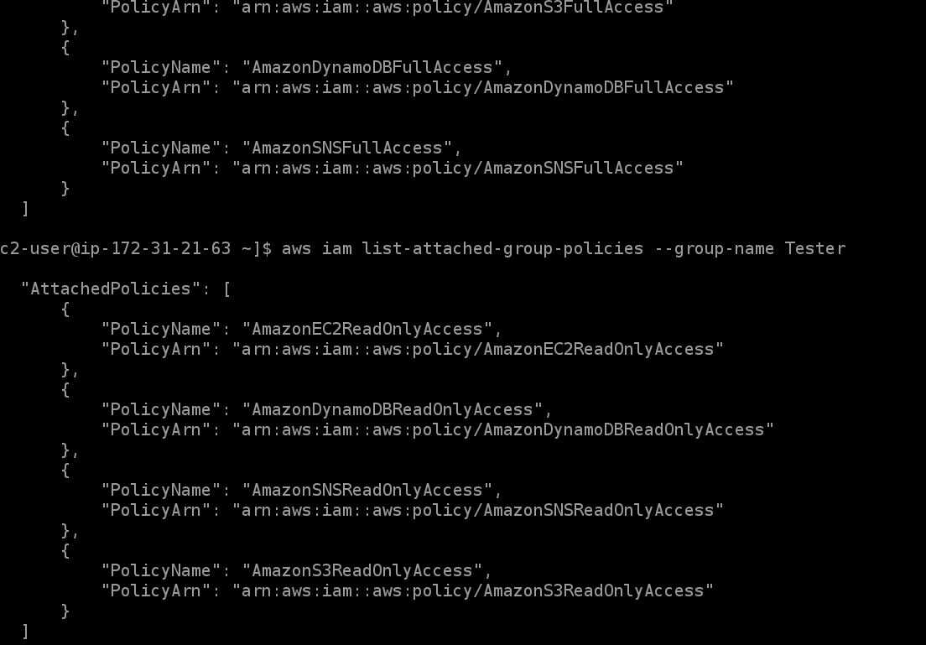

Add the users to the correct groups, use the CLI to show the correct users are in each group, and take   
**SCREENSHOT.**

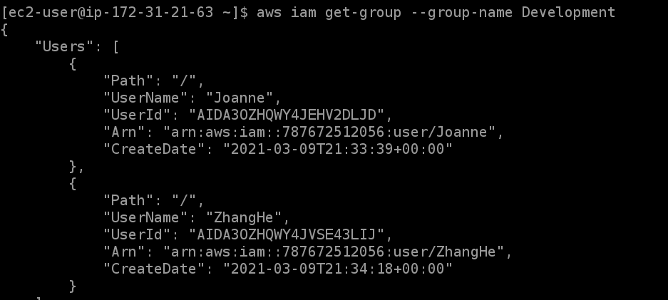

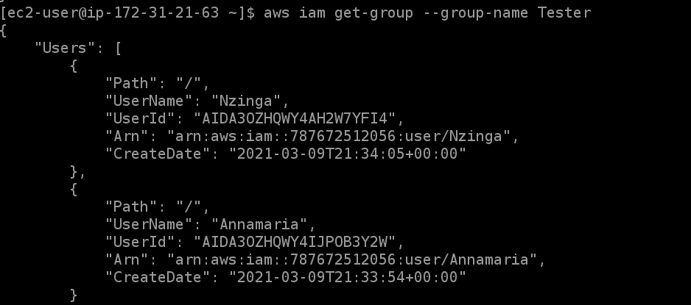

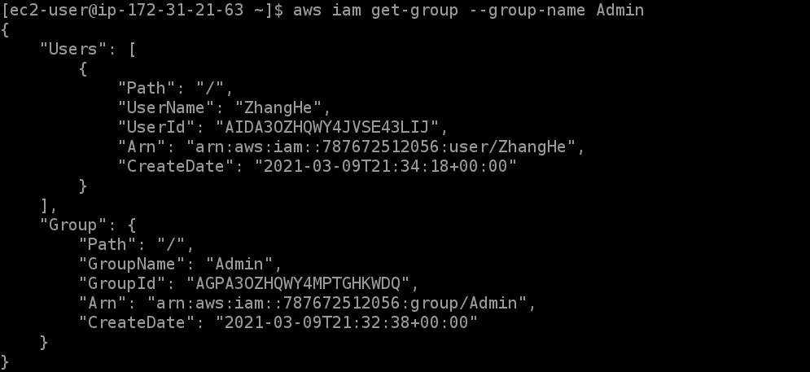

**Step 4: Amazon EC2**

Create an Amazon EC2 instance that is running Amazon Linux 2, that is a T2.Micro with the tags  
Name: Development  
Webserver: Apache

Create an Amazon EC2 instance that is running Amazon Linux 2, that is a T2.Micro with the tags  
Name: Test  
Webserver: Database



**Step 5: S3**

Create an S3 bucket with a Unique name for the Developers that has “Development” in the name.

**Attach a SCREENSHOT of the bucket creation output**



Create an S3 bucket with a Unique name for the Test that has “Test” in the name.

**Attach a SCREENSHOT of the bucket creation output**



**Step 6: DynamoDB**

Create a DynamoDB Table

With the name “OurAwesomeProject”  
With the attributes:

Name (string)

Date (string)

Tested (Boolean)

The partition key will use the NAME attribute

The sort key will use the DATE attribute

Take a **SCREENSHOT** of the describe-table output.

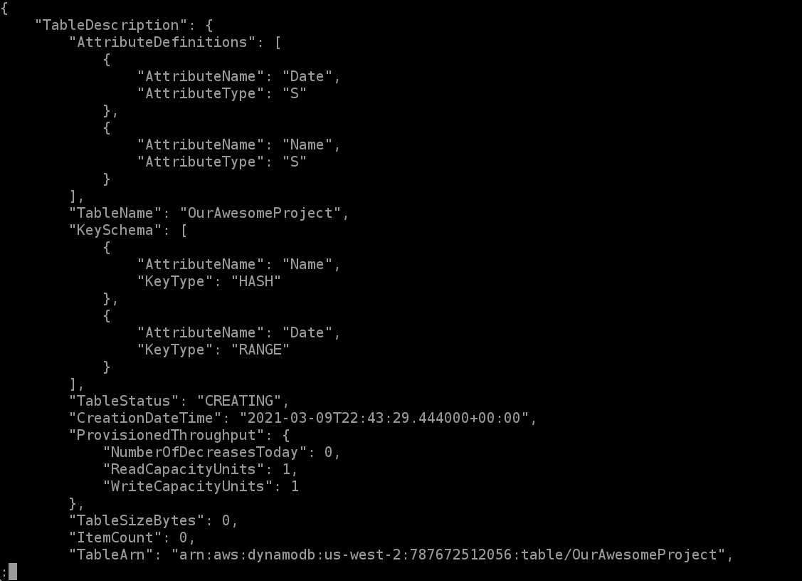

**Step 7: Cleanup**

**Use the AWS CLI to delete the following resources**

DynamoDB table

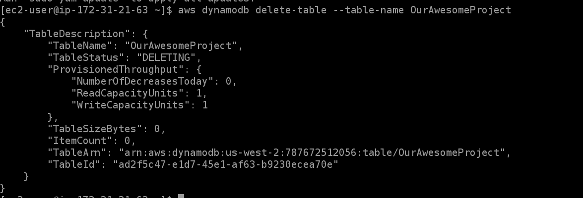

2 S3 buckets we created

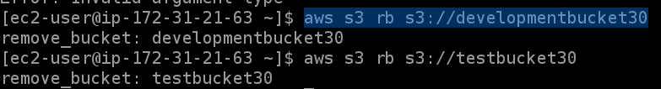

Terminate the EC2 instances



Delete the two developers access keys **TAKE A SCREENSHOT TO CONFIRM**

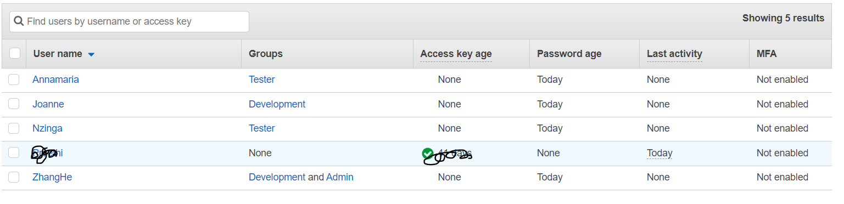

Delete the 4 users

Delete the 3 groups

